Celebrate Literacy Week, Florida
January 24th-28th
We will participate in many activities throughout the week to encourage and support literacy across curriculum.

Monday, January 24th- Mission Monday
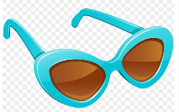
We will be “blasting off into space and reading about saving our planet. Students wear sunglasses and brightly colored clothing.
Tuesday, January 25th- Tuesday #Trashtag
We will be reading to help raise awareness and encourage others to do good for our planet. Students wear green for “Going Green!”.
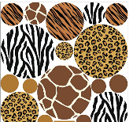
Wednesday, January 26th- Wild About Reading
We will be reading a mystery or a scientific text and conducting a science experiment. Students wear their favorite animal print or attire.
Thursday, January 27th- Leaders are Readers
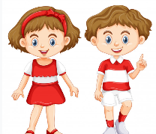
We will read a biography about someone in science, space, engineering, or math. Students wear red and be “Well Read”.
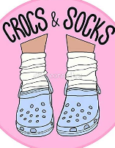
Friday, January 28th- Crocs and Socks
We will be sharing how Crocs and socks were both created through technology. Students wear their favorite Crocs and/or socks.

We encourage you to read about these topics at home as well. Take a picture of you and/or your child reading and send to #DPESReads.
Celebrate Literacy Week, Florida
January 24th-28th
We will participate in many activities throughout the week to encourage and support literacy across curriculum.
Monday, January 24th- Mission Monday | “One small step for man, one giant leap for mankind”  - Read a book about saving our planet  - Blasting off into space can be bright. Wear sunglasses and brightly colored attire.  - CS- Create a space scene with characters that 'emote' to share their thoughts or feelings using sounds, colors, and actions.
Tuesday, January 25th- Tuesday #Trashtag | - Share a photo and/or a good read to help raise awareness and encourage others to do good for the planet  - Wear green for Going Green!  - Recite the Reader’s Oath
Wednesday, January 26th- Wild About Reading | “Houston, we have a problem”  - Read a mystery Or Read a scientific text to complete a science experiment  - Go wild about reading. Wear your favorite animal print or attire.
Thursday, January 27th- Leaders are Readers | Hidden Figures  - Read a biography about someone in science, space, engineering, or math  - Students tweet your favorite book titles and/or quotes.  - Wear red and be “Well Read”
Friday, January 28th- Crocs and Socks | Technology made both Crocs and socks possible  - Share a photo and tell us the most interesting part of the design of socks and/or Crocs.  - Wear your favorite Crocs and/or socks.
We encourage you to read about these topics with your students this week. Books will be on display and available for checkout in the library. Send pictures of your readers throughout the week to #DPESReads.

